

USER MANUAL

Venn Diagram



Varuhn Ruthirakuhan - 215634140

Abdalah Yusuf -216516718

Uchechukwu Madu - 214507800

# Table of Contents

**Table of Contents: 1**

**Installation:** 3

**Getting Started:** 4

Selecting colour 7

Selecting size 8

Data Input 9

Saving Data 10

Modifying the Venn Diagram 11

# Installation:

The product application can be installed on any device that is capable of running the Java Virtual Machine through the Java Applet. The application allows the interface to interact with the specified libraries needed.

To install the Venn Diagram Application prototype, start by downloading the application from [[Venn_Diagram1.jar](https://drive.google.com/file/d/1UuH6Kh3DAbsHVbFa5Q4lg1z3KV1MnlZe/view?usp=sharing)] as a ZIP file and extract the Prototype to your directory of choice. By clicking the link you will get the pop-up as seen below where you can then click the blue button “Download” to download the file.

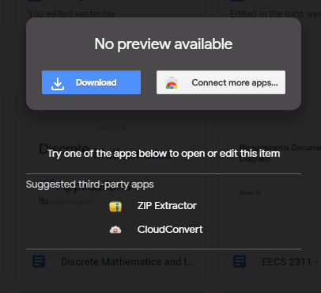

Then, to launch the application double click the .jar file.

# Getting Started:

The Venn Diagram Application can be controlled by using the prompt panel.

Below is the panel that comes up. Here is the panel where users can select the name of their topics. Then users can set their comparison topics for “First Topic”, “Second Topic”, and “Set Title” titles to then launch the application as shown below.

1. Launch Application

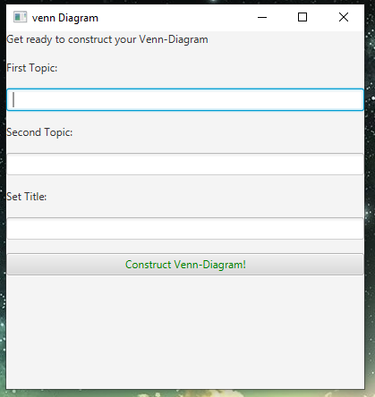

Fig 1 - First Panel

2) Select Your Topic’s name and Select your Title then click the button “Construct Venn-Diagram!”

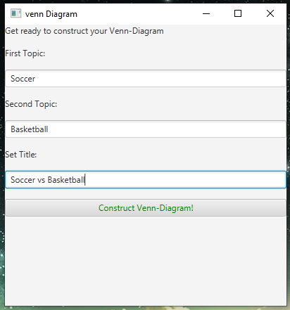

Fig 2 - First Panel with sample input

When users reach the step below, users can see their Topic 1 and Topic 2 names. Users also should be able to see their Title in the top middle of the screen. In our cases we are using Soccer vs Basketball as an example for the rest of the manual.

Fig 3 - Second Panel after receiving input values from Fig 2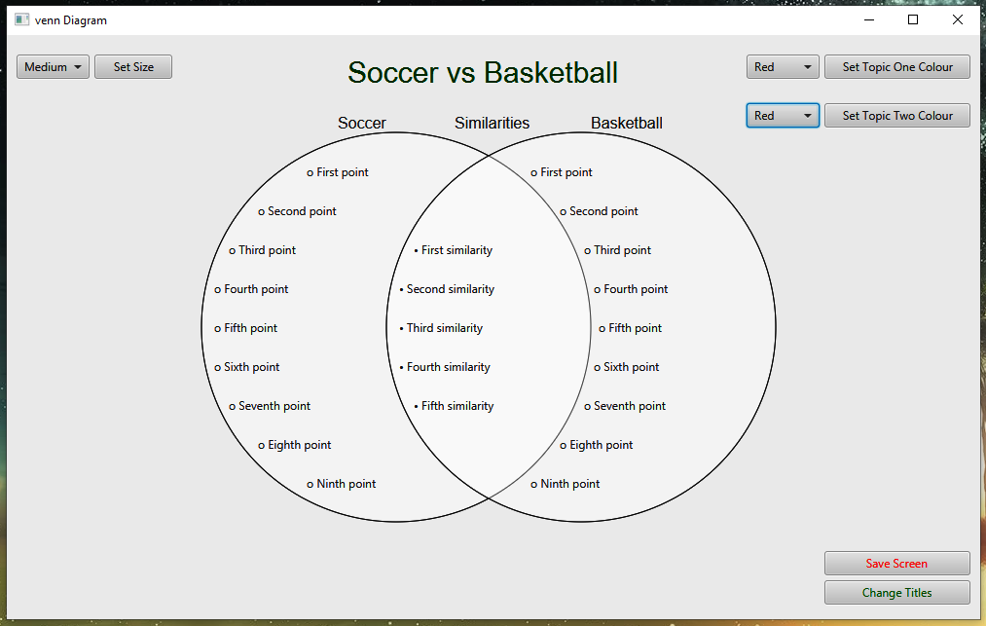

**Selecting colour**

Users have the option of selecting a colour from the colour panel. Users also have the choice of staying with the Manuel colour. However, to change a colour, users can select the colour panel on top right corner. The steps are shown below.

1. Select your colour of choice for Topic one from the drop-down menu
2. Select the set Topic One Colour
3. Select your colour of choice for Topic two from the drop-down menu
4. Select the set Topic two Colour

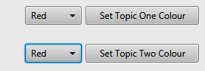

Fig 4 - Set colour options on top right of application

The colours available in each drop down menu are: white (default), red, yellow, orange, green, blue, indigo, violet.

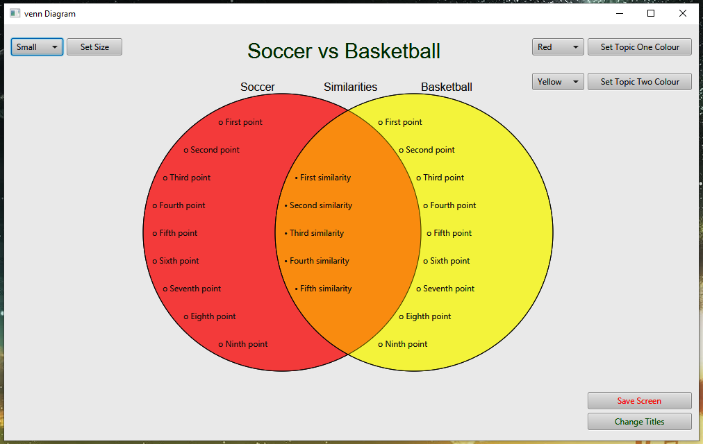

Fig 5 - Sample colour inputs for Topic One and Topic Two

**Selecting size**

The Venn Diagram has 3 sizes to choose from: “Small”, “Medium” (default) , or “Large”. Each size has a number of points that users can input. For example, the small icon has 5 input points. Below users are shown how to navigate between sizes.

To change size, click on the drop down menu seen in the top left corner and select the appropriate size then, click on the button “Set Size”.

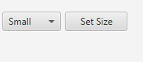

Fig 6 - Drop down menu and “Set Size” button seen on top left of application

Fig 7 - Sample “Large” size for Venn diagram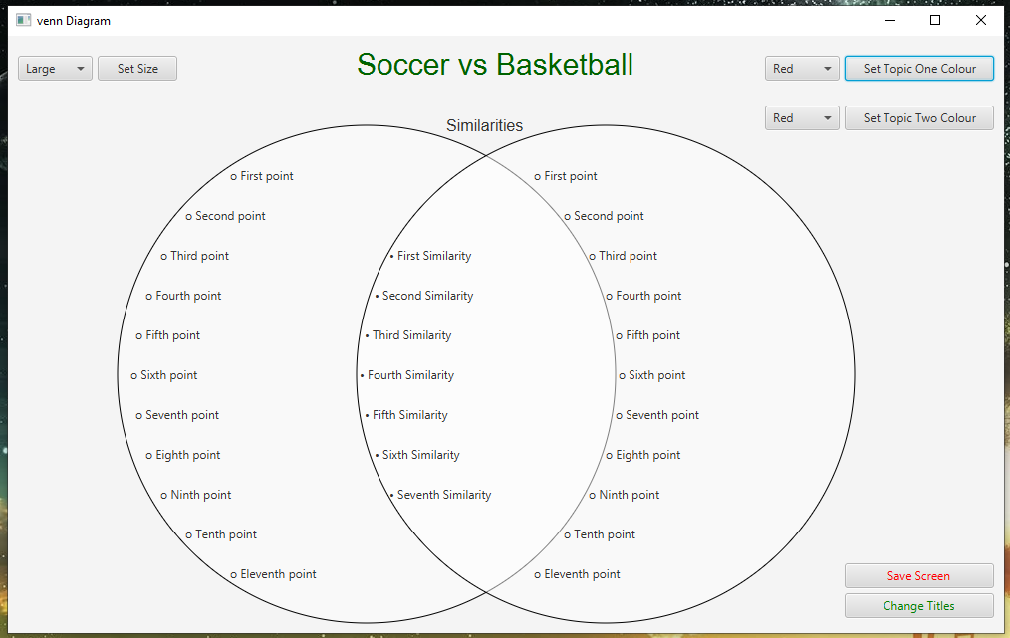

**Inputting Data**

Once users have their desired size, users can start to input data into the topic’s points and their similarities. To input data users double click the “First point” Icon and start to input their own data as Shown below.

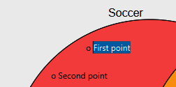

Fig 8.1 - Highlighting First Point

Fig 8.2- Deleting First Point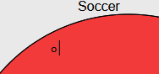

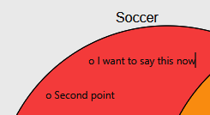

Fig 8.3- Inputting User Data

****Fig 8.3- Deleting User Input

**Saving Data**

Once users have inputted Data and decide to save their Data they easily do so, by clicking the “ Save Screen button”. This feature also allows users to save their Venn diagrams. This feature makes it easy for users to see their past Diagram. The steps to saving users Data are shown below.

1. Click the “Save Screen” Button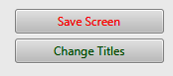

Fig 9.1- “Save Screen” Button and “Change Titles” Button seen on bottom right of the panel.

The user can also click on the “Change Titles” button if they wish to go back to Panel 1 seen on “Figure 2” if they wish to change the title and/or topic names.

## 

## 

## 

## 

## 

## 

## 

## 

## 

## 

## 

## 

## 

## 

## 

Fig 9.1- Saved Data Screen

The window can also be expanded to see the full application display.

Modifying the Venn Diagram:

Modifying the Venn Diagram is a great way to allow users to customize their Venn Diagram experiences. Users can always change their colour and size by following the steps above. Also, users have the ability to change their title after selecting it, to a new title of their choice.